City of Oak Hill | 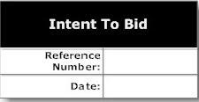
c/o William Hannabass
100 Kelly Ave., Oak Hill, WV 25901

We are notifying the City of Oak Hill of
our intention to submit a sealed bid on or before

Date: December 12, 2022 Time: Prior to 3 p.m.

A copy of my WV Contractor License and Liability Insurance will be submitted with my sealed bid.

We acknowledge that we have read, understand, and agree with the requirements that
have been presented in the Notice to Bidders published in the Fayette Tribune and
oakhillwv.gov website regarding the demolition of the structure located at

146 Richards St. (Reference #30)
Company Name: ____________________________________
Address: _________________________________________
City, State, & Zip: __________________________________
Phone:__________________ Email: _____________________

Signature: _______________________________________
Title: _______________________________________________
Contractor's License: ________________________________

Email Completed Form to

rfalk@oakhillwv.gov

Email Completed Form to

rfalk@oakhillwv.gov

