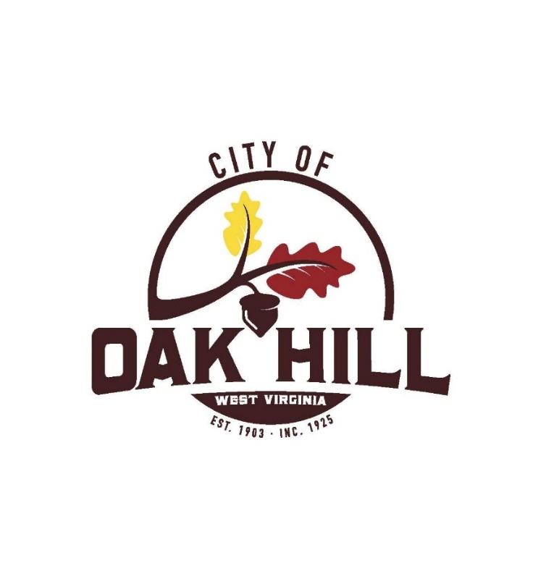__________ __________

Paving Advertisement for Bids

The City of Oak Hill, WV will accept sealed, itemized proposals until 4:00 pm on Monday August 11, 2025, for the paving of the following streets:

Anderson St., Arthur St., Beech Ave., Burke Ave., Byrnside St., East Martin Ave. including widening, Martin Ave., Trump Ave., Webster Ave., Needleseye Park Parking Lot Entrance

Please follow the link  <https://arcg.is/1mWaiu> to view the street map.

Bids received after the designated time and date will be returned unopened. Bids must be either mailed to: Attn: City Manager / Paving Bid PO Box 1245, Oak Hill, WV 25901 or you may deliver the sealed bid to City Hall located at 100 Kelly Ave., Oak Hill, WV 25901.

The City of Oak Hill reserves the right to reject any and all bids and to waive any and all technicalities. Proof of $1,000,000 liability insurance and 5% Bid Bond is required at time of bid.

A mandatory pre-bid conference will be on Tuesday July 8, 2025 @ 1:00 pm in the Council Chambers at Oak Hill City Hall, 100 Kelly Avenue, Oak Hill, WV.

Bid opening and consideration of award will be at the City Council meeting on Monday August 11, 2025 or soon thereafter.

Gretchen Brown

Gretchen Brown, City Clerk-Treasurer